Topology Qualifying Exam, Aug. 14, 2008

Instructions
Justify all the calculations in your answers.

Problems
- Let $A$ be a proper subset of $X$ and let $B$ be a proper subset of $Y$. If $X$ and $Y$ are connected show that $(X×Y)-(A×B)$ is connected.
- Recall that a topological space is said to be regular if every point $p$ and every closed set $F$ which does not contain $p$ can be separated by open sets.
  - Prove that a subset of a regular space is regular.
  - Give an example of a Hausdorff space which is not regular.
- Let $Y$ be $S^{2}×[0,1]$. Let $X$ be the space obtained by cutting three tunnels out of this spherical shell; in other words, $X=Y\backslash ⋃_{i=1}^{3}\left(D_{i}^{2}×[0,1]\right)$, where the $D_{i}$ are three small open discs in $S^{2}$. (The surface is shown below.) What is the genus of the boundary of $X$? Justify your answer.
- 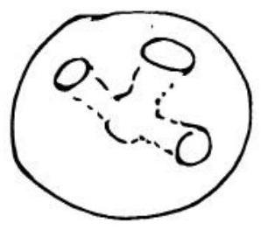
- Let $X$ be the quotient space of the annulus obtained by identifying antipodal points on the outer circle and points on the inner circle which are $120$ degrees apart. What is $π_{1}(X)$?
- List all of the $3$-fold covering spaces of $Σ_{2}$ (the closed orientable surface of genus $2$). Explain why your list contains all possible $3$-fold covers.
- Compute $π_{1}$ and the homology of the singular surface in the picture created by joining $n$ "footballs" end to end in a ring. Each "football" meets the next in a single point.
- 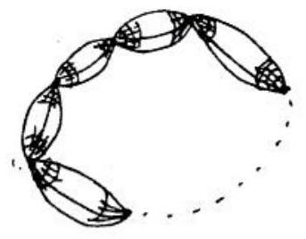
- Use the Mayer-Vietoris sequence to compute the homology groups $H_{i}(S^{n})$ for all $i$ and all $n>0$.
- Let $f:S^{n}→S^{n}$ be a map without fixed points. What is the degree of $f$? Explain.
- Let $α_{pq}⊂S^{1}×S^{1}$ be the image of the line $y=\frac{q}{p}x⊂R^{2}$ under the standard projection $R^{2}→S^{1}×S^{1}$ (given by $(x,y)∼(x+m,y+n)$ for all $m,n∈Z$). Calculate the homology of $\left(S^{1}×S^{1}\right)/α_{pq}$.

